Top 10 Suggestions for Increasing
Capacity Building Volunteers

- Get senior management on your side. Tell success stories about saving money, making money, doing more mission.
- Build staff, board, and volunteer allies for capacity building volunteers. Collaborate closely with staff in development and communications.
- Provide staff training on how to engage and supervise volunteers.
- For grants – include money for volunteer management.
- Include staff in assessing volunteer engagement opportunities. They must be believers.
- Start with piloting new uses of volunteers; then show the results.
- Use the word “volunteer” sparingly for capacity building volunteers.
- Make capacity building volunteers feel part of the team and encourage them to own their work. Make them seamless with staff. Provide them with business, cards, phone number, etc…)
- Verify volunteer competency/dedication, then trust them.
- Look for Longer Term Volunteers - Consider targeting 63 to 75 year olds for longer term capacity building assignments.
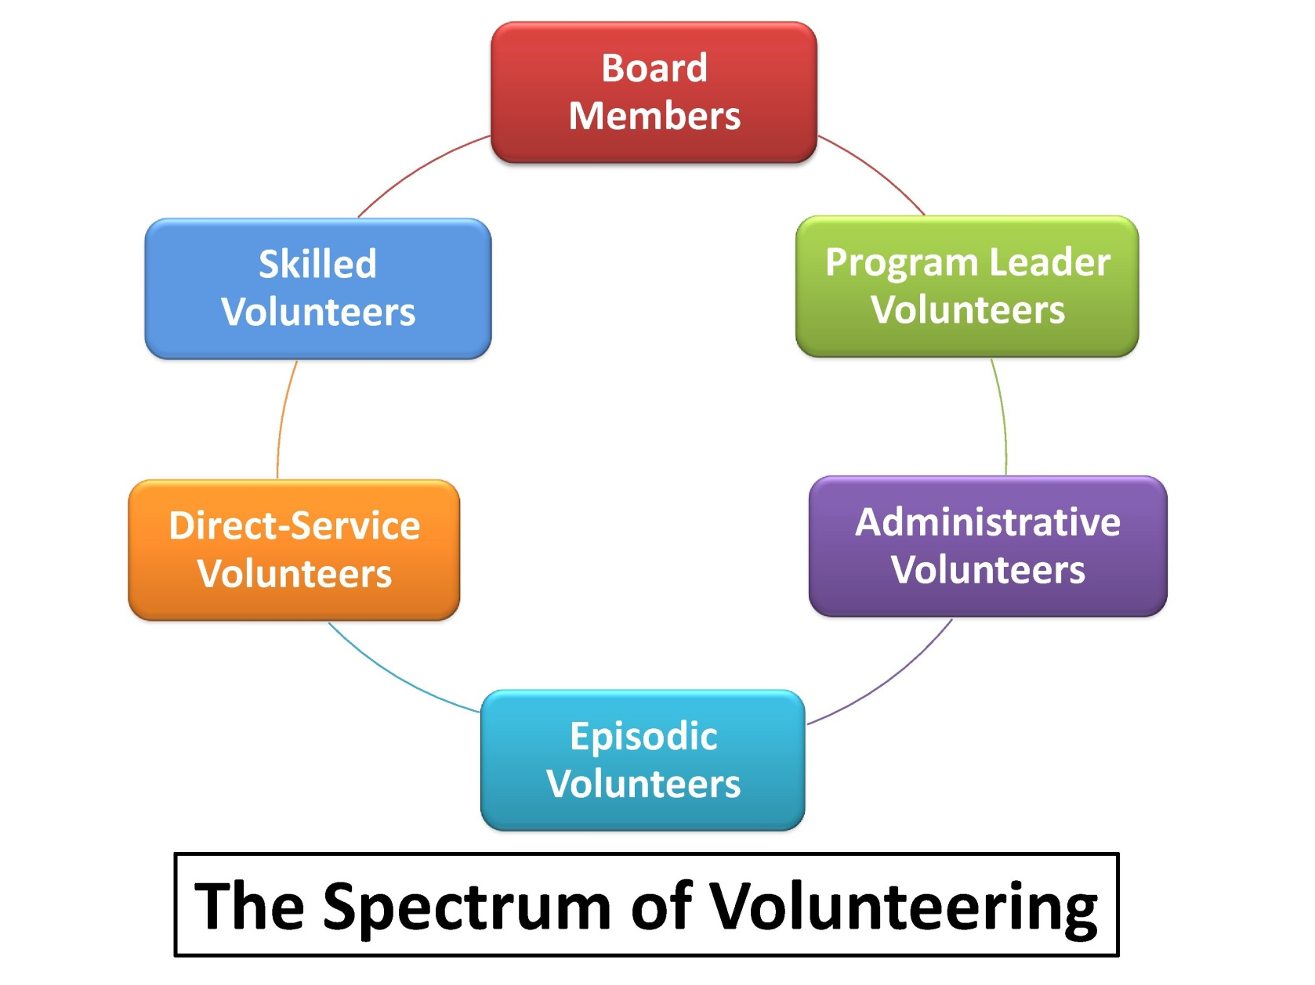
Visit: www.VolunteerFrontier.com for more resources.

